**CONVERTER**

1. Converter::toDescriptorVector

This function takes a single cv::Mat object containing multiple descriptors (rows in the matrix) and converts it into a std::vector of individual descriptors, where each descriptor is represented as a single row of the input matrix. It allows each row (descriptor) to be accessed and manipulated as an independent cv::Mat.

**Inputs**

* **Descriptors**: A cv::Mat object (typically from OpenCV) where each row represents a descriptor (e.g., a feature vector from an image, such as SIFT, SURF, or ORB descriptors).

**Outputs**

* **vDesc**: A std::vector<cv::Mat> where each element is a single-row cv::Mat (corresponding to one descriptor from the input Descriptors matrix).



This reserves enough space in vDesc to store all rows of the input Descriptors matrix. This avoids dynamic memory allocations during the push-back operations, improving performance.

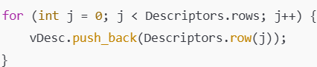

For each row, it uses Descriptors.row(j) to extract the row as a single-row cv::Mat and appends it to the vDesc vector.

1. Converter::isRotationMatrix

The function checks whether a given cv::Mat matrix RRR is a valid **rotation matrix.**

**What is a Rotation Matrix?**

A rotation matrix R is a 3×3 orthogonal matrix that satisfies the following properties:

1. **Orthogonality**:  
   R^T . R = I, where R^T is the transpose of R, and I is the identity matrix.
2. **Determinant**:  
   det(R)=1

This function checks the first property (orthogonality), which is often sufficient to determine if a matrix is likely a rotation matrix.

Steps:

* Transpose the Input Matrix

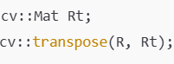

* Multiply Transpose with the Original Matrix



* Create an Identity Matrix



* Compare with the Identity Matrix



The function calculates the difference (using cv::norm) between I and Rt⋅R. If the difference is less than a small threshold (1e-6), the function concludes that R is a rotation matrix and returns true.

1. Eigen::Matrix<double,3,1> Converter::toVector3d(const cv::Mat &cvVector)

This function converts 3- dimensional vector stored in a cv::Mat into an Matrix, which is of size 3x1 (double-precision floating-point) using Eigen library.

* **Input**: A cv::Mat object (cvVector) that represents a 3-dimensional vector.
* **Output**: An Eigen::Matrix<double, 3, 1> object (v), which is the equivalent 3D vector representation in the Eigen library, with elements stored as double.

Steps:

* Define an Eigen 3D Vector



* Populate the Eigen Vector



**Access Elements in cv::Mat:** The cvVector.at<float>(i) accesses the i-th element of the cv::Mat input vector.

1. Eigen::Matrix<float,3,1> Converter::toVector3f(const cv::Mat &cvVector)

This function converts 3- dimensional vector stored in a cv::Mat into an Matrix, which is of size 3x1 (single-precision floating-point) using Eigen library.

* **Input**: A cv::Mat object (cvVector) that represents a 3-dimensional vector.
* **Output**: An Eigen::Matrix<float, 3, 1> object (v), which is the equivalent 3D vector representation in the Eigen library, with elements stored as float.

Steps:

* Define an Eigen 3D Vector



* Populate the Eigen Vector

**Access Elements in cv::Mat:** The cvVector.at<float>(i) accesses the i-th element of the cv::Mat input vector.

1. Eigen::Matrix<double,3,1> Converter::toVector3d(const cv::Point3f &cvPoint)

This function converts a 3D point (a point with float coordinates x,y,z) into an Eigen (a 3x1 column vector with double precision).

**Input**:

* A cv::Point3f object (cvPoint), which represents a point in 3D space using single-precision floating-point numbers (x,y,z).

**Output**:

* An Eigen::Matrix<double, 3, 1> object (v), which represents the same point as a 3x1 vector using double-precision floating-point numbers.



Access the x, y, and z components of the cv::Point3f object cvPoint. Assign these values to the Eigen vector v using Eigen's initialization syntax (<< operator).

1. Eigen::Matrix<double,3,3> Converter::toMatrix3d(const cv::Mat &cvMat3)

This function converts a 3x3 matrix (with elements assumed to be of type float) into an **Eigen** (a 3x3 matrix with elements stored in double precision).

**Input**:

* A cv::Mat object (cvMat3) representing a 3x3 matrix in OpenCV format, where elements are stored as float.

**Output**:

* An Eigen::Matrix<double, 3, 3> object (M), which is the equivalent 3x3 matrix in Eigen format, with elements converted to double precision.

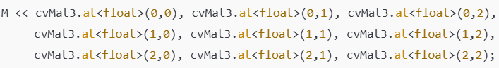

The matrix elements are accessed from the OpenCV cv::Mat object using cvMat3.at<float>(i, j), where i is the row index and j is the column index. These elements are then assigned to the corresponding positions in the Eigen matrix M using Eigen's initialization syntax (<< operator). Each element is implicitly converted from float to double precision during assignment. A 3x3 matrix is returned.

1. Eigen::Matrix<double,4,4> Converter::toMatrix4d(const cv::Mat &cvMat4)

This function converts a 4x4 matrix (with elements assumed to be of type float) into an **Eigen** (a 4x4 matrix with elements stored in double precision).

**Input**:

* A cv::Mat object (cvMat4) representing a 4x4 matrix in OpenCV format, with elements stored as float.

**Output**:

* An Eigen::Matrix<double, 4, 4> object (M), which is the equivalent 4x4 matrix in Eigen format, with elements converted to double precision.



Each element of the input cv::Mat is accessed using cvMat4.at<float>(i, j) and are assigned to M and data type will be changed from float to double. A 4x4 matrix is returned.

1. Eigen::Matrix<float,3,3> Converter::toMatrix3f(const cv::Mat &cvMat3)

This function converts a 3x3 matrix (with elements assumed to be of type float) into an **Eigen** (a 3x3 matrix with elements stored in single precision).

**Input**:

* A cv::Mat object (cvMat3) representing a 3x3 matrix in OpenCV format, where elements are stored as float.

**Output**:

* An Eigen::Matrix<float, 3, 3> object (M), which is the equivalent 3x3 matrix in Eigen format.



The matrix elements are accessed from the OpenCV cv::Mat object using cvMat3.at<float>(i, j). These elements are then assigned to the M. A 3x3 matrix is returned.

1. Eigen::Matrix<float,4,4> Converter::toMatrix4f(const cv::Mat &cvMat4)

This function converts a 4x4 matrix (with elements assumed to be of type float) into an **Eigen** (a 4x4 matrix with elements stored in single precision).

**Input**:

* A cv::Mat object (cvMat4) representing a 4x4 matrix in OpenCV format, with elements stored as float.

**Output**:

* An Eigen::Matrix<float, 4, 4> object (M), which is the equivalent 4x4 matrix in Eigen format.



Each element of the input cv::Mat is accessed using cvMat4.at<float>(i, j) and are assigned to M. A 4x4 matrix is returned.

1. std::vector<float> Converter::toQuaternion(const cv::Mat &M)

This function converts a 3x3 rotation matrix into a quaternion representation. The quaternion is returned as a std::vector<float> containing the components of the quaternion.

**Input**:

* A cv::Mat (M) representing a 3x3 rotation matrix.

**Output**:

* A std::vector<float> containing the quaternion components [x, y, z, w], where:
  + x,y,z represent the vector part of the quaternion.
  + w represents the scalar (real) part.

Steps:

1. **Convert OpenCV Matrix to Eigen Matrix**:



This converts a 3x3 matrix (with elements of type float) into an **Eigen** (a 3x3 matrix with elements stored in double precision).

1. **Convert Eigen Matrix to Quaternion**:



The Eigen::Quaterniond constructor accepts a 3x3 rotation matrix and computes the corresponding quaternion (q). This function returns the values based on the angle of rotation and about which axis(x or y or z).

* Trace of the Matrix, T=R00​+R11​+R22​
* If T>0: Use a formula to directly compute w (the scalar part of the quaternion). 

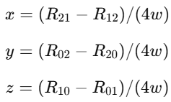

* If T≤0: Use the largest diagonal element of R (among R00,R11,R22​) to determine which component (x,y,z) to calculate first.

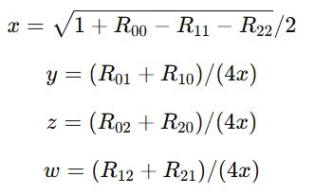

If R00 is largest, x will be calculated 1st and will be used for calculation of y,z and w, and if others are largest, the formula should be applied similarly.

1. **Extract Quaternion Components**:

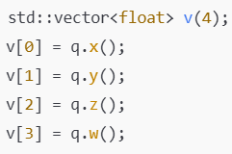

x,y,z represent the vector part of the quaternion. w represents the scalar part.

1. cv::Mat Converter::tocvSkewMatrix(const cv::Mat &v)

This function generates the **skew-symmetric matrix** of a given 3D vector v.

**Input**

* v: A 3x1 column vector represented as an OpenCV cv::Mat object. It contains the three components vx​, vy​, and vz.

**Output**

* A 3x3 skew-symmetric matrix, created from the vector v.

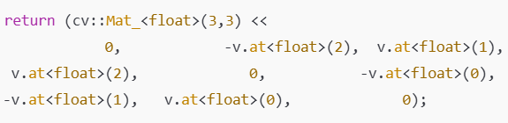

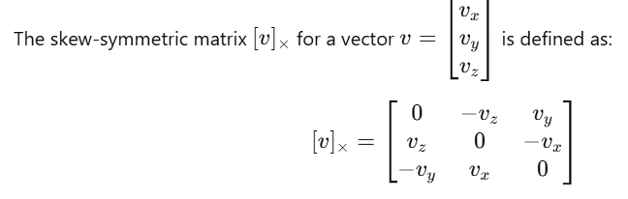

1. std::vector<float> Converter::toEuler(const cv::Mat &R)

This function extracts **Euler angles** from a given 3x3 **rotation matrix** R. Euler angles describe the orientation of a 3D object by three rotations about the principal axes (usually x, y, and z axes) in a specific order.

**Inputs**

* A 3×3 rotation matrix R.
* It assumes RRR is a valid rotation matrix (checked using isRotationMatrix).

**Steps**

1. **Verify Rotation Matrix**:



1. **Compute sy**:



sy is the norm of the first column of R (excluding the z-axis component). It represents the magnitude of the cosine of the pitch angle y. A small sy indicates a singularity.



1. **Check Singularity**:



In this state, the roll (z) and yaw (x) axes align, causing a loss of rotational information if sy=0 which is singular and also called as gimbal lock, else non-singular.

1. **Extract Euler Angles**:

**Non-singular case**:

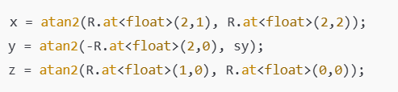

**Singular case**:

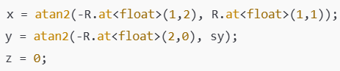

Due to gimbal lock, the z-axis rotation is set to 0, and the remaining angles are computed.

atan2 function:



Returns the angle θ in radians between the positive x-axis and the line connecting the origin to the point (x,y).

1. **Return Euler Angles**:

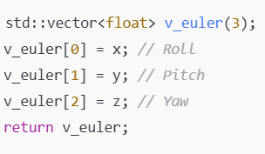

1. Sophus::SE3<float> Converter::toSophus(const cv::Mat &T)

This function converts a transformation matrix (homogeneous 4x4 matrix) to the **Sophus** representation, which is used for handling **SE(3)** transformations (which combines rotations and translations in 3D space).

**Input: cv::Mat T (Transformation Matrix)**

* The matrix T is a 4x4 **homogeneous transformation matrix** that represents a rigid transformation in 3D space. It contains both the rotation and translation components.
* The matrix format looks like this:

where R3x3 is the rotation matrix (3x3), and t3x1​ is the translation vector (3x1).

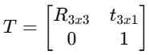

Step 1: Extract Rotation and Convert to Eigen Matrix



T.rowRange(0, 3).colRange(0, 3) extracts the top-left 3x3 portion of the 4x4 matrix, which corresponds to the **rotation matrix** R3x3​. The toMatrix3d function is used to convert the cv::Mat of type float to an **Eigen 3x3 matrix** of type double. The conversion is done to ensure compatibility with Sophus (which internally uses double precision matrices).

Step 2: Convert the Rotation Matrix to a Quaternion



The extracted 3x3 rotation matrix eigMat is cast to float and used to construct an **Eigen Quaternion** (Eigen::Quaternionf). The **quaternion** q represents the **rotation** part of the transformation. Quaternions are used to avoid issues like gimbal lock and are more computationally efficient than Euler angles for rotations.

Step 3: Extract Translation and Convert to Eigen Vector



T.rowRange(0, 3).col(3) extracts the last column of the matrix T (excluding the bottom row), which corresponds to the **translation vector** t3x1​. The toVector3d function is used to convert the cv::Mat representing the translation into an **Eigen vector**. The .cast<float>() converts the vector to float type to match the Sophus::SE3<float> format.

Step 4: Return the SE(3) Object



The **Sophus::SE3<float>** object is constructed using the quaternion q (rotation) and the (translation) vector t. It combines both the rotation (as a quaternion) and the translation (as a vector) into a single object that can be used for further transformations, operations like interpolation, and applying transformations to points or objects. Sophus::SE3<float> is a Sophus class that represents the **SE(3)** group (Special Euclidean group), which is the group of rigid-body transformations consisting of a rotation and a translation.

1. Sophus::Sim3f Converter::toSophus(const g2o::Sim3& S)

This converts a **Sim3** transformation from the **g2o** library to a **Sophus::Sim3f** transformation in the **Sophus** library.

g2o::Sim3 includes:

* **Scale**: A scalar factor that represents uniform scaling.
* **Rotation**: A 3x3 rotation matrix that defines the 3D rotation.
* **Translation**: A 3D translation vector.

The Sim3 class in g2o represents a **similarity transformation**, g2o is a framework used for optimizing graphs in **SLAM (Simultaneous Localization and Mapping)** or other optimization problems.

Sophus::Sim3f represents a **Sim3 transformation** in Sophus and includes:

* **Rotation** (represented as an SO(3) element).
* **Translation** (represented as a 3D vector).
* **Scaling** (represented as a scalar).

1. **Scale Extraction**:

* S.scale() extracts the scaling factor from the g2o Sim3 object. This is a scalar value that represents the scaling applied to the transformation.

1. **Rotation Matrix Extraction**:

* S.rotation().matrix() gets the 3x3 rotation matrix from the Sim3 object.
  + S.rotation() gives an object that holds the 3D rotation information, typically a **rotation matrix** or a **quaternion**.
  + .matrix() converts this rotation object into a standard 3x3 matrix.

1. **Creating Sophus Rotation Object**:

* Sophus::RxSO3d is used to represent a rotation in **SO(3)**. SO(3) is the special orthogonal group, which describes rotations in 3D space.
  + Sophus::RxSO3d((float)S.scale(), S.rotation().matrix()) creates a rotation object from the extracted rotation matrix.
  + The rotation matrix is **cast** to a float (cast<float>()) to ensure the data type is consistent with the Sophus::Sim3f type, which expects float precision.

1. **Translation Extraction**:

* S.translation().cast<float>() extracts the 3D translation vector from the Sim3 object and casts it to a float type.

1. **Creating Sophus::Sim3f Object**:

* The Sophus::Sim3f object is constructed using the following components:
  + The rotation object (Sophus::RxSO3d) created from the rotation matrix.
  + The translation vector (S.translation()).

The scale factor is implicitly handled by Sophus::Sim3f since **Sim3 transformations** involve scaling, rotation, and translation.

1. g2o::SE3Quat Converter::toSE3Quat(const cv::Mat &cvT)

The function converts a **3x4 transformation matrix**, representing a **rigid body transformation** with rotation and translation, into a **g2o::SE3Quat** object, which is used in the **g2o** library for 3D transformations.

* 1. **Input: cv::Mat Transformation Matrix (cvT)**:
* The input cvT is expected to be a **3x4 transformation matrix**. This matrix typically consists of a **3x3 rotation matrix** and a **translation vector**
  1. **Extracting the Rotation Matrix (R):**
* The function extracts the first 3x3 part of the matrix cvT, which is the rotation matrix

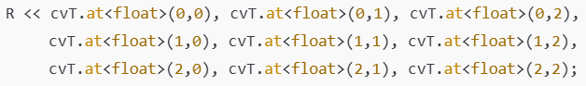

* 1. **Extracting the Translation Vector (t)**:



* 1. **Returning the g2o::SE3Quat Object**:
* **SE(3)** is the Lie group representing **rigid body transformations** (rotation + translation) in 3D space. This function defines the angle of rotation based on the rotation matrix and the translation in x, y and z-axis based on the translation matrix values.

1. g2o::SE3Quat Converter::toSE3Quat(const Sophus::SE3f &T)

The function converts a Sophus SE3f object (which represents a 3D transformation) to a g2o::SE3Quat object (which is also used to represent 3D transformations, but in the g2o optimization framework).

Input: SE3f is a transformation represented by a unit quaternion and translation vector.

Steps:

* T.unit_quaternion().cast<double>() -> it retrieves the rotation part of the SE3f object which is a unit quaternion and converts it from float to double precision.
* T.translation().cast<double>() -> it retrieves the translation vector of a transformation as a Eigen::Vector3f (a 3D vector in float) and then converting it to double precision.
* g2o::SE3Quat(T.unit_quaternion().cast<double>(), T.translation().cast<double>()) -> it returns a g2o::SE3Quat object which has **unit quaternion** representing rotation and **translation vector** which will be in g20 format**.**

1. cv::Mat Converter::toCvMat(const g2o::SE3Quat &SE3)

This function converts a **g2o::SE3Quat** object (which represents a 3D transformation) into an **OpenCV cv::Mat** object, specifically a **4x4 homogeneous transformation matrix**.

* **Input: g2o::SE3Quat &SE3**
  + SE3Quat is a class in the g2o optimization framework that represents a 3D transformation in the form of a **rotation** (as a quaternion) and **translation** (as a 3D vector).
* SE3.to_homogeneous_matrix() converts the SE3Quat object into a **4x4 homogeneous transformation matrix**. This matrix is a **combination of rotation and translation**.

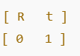

R is a 3x3 rotation matrix (from the quaternion), t is a 3x1 translation vector (from the translation), The last row [0, 0, 0, 1] is used to make the transformation homogeneous.

* The toCvMat() function converts the **Eigen matrix** into an OpenCV matrix (cv::Mat), which can be used for further processing in OpenCV.

1. cv::Mat Converter::toCvMat(const g2o::Sim3 &Sim3)

The function converts a **g2o::Sim3** object into an **cv::Mat** object. The **g2o::Sim3** class represents a **similarity transformation** in 3D, which includes:

* **Rotation**: A 3x3 rotation matrix (or a quaternion-based rotation),
* **Translation**: A 3x1 translation vector,
* **Scale**: A scalar value that scales the transformation.

Step 1: Extract the Rotation



The rotation is extracted using Sim3.rotation(), which gives an **Eigen quaternion** representing the rotation part of the transformation. toRotationMatrix() converts the quaternion into a **3x3 rotation matrix** (eigR).

Step 2: Extract the Translation



The translation is extracted using Sim3.translation(), which returns a **3D translation vector** (eigt).

Step 3: Extract the Scale



The scale factor is extracted using Sim3.scale(), which returns a **scalar** value (s) that scales the rotation and translation.

Step 4: Call toCvSE3(s*eigR, eigt)



The scale s is multiplied with the rotation matrix eigR to apply the scaling to the rotation part. The function then calls another function, toCvSE3(s*eigR, eigt), which is responsible for combining the scaled rotation matrix and translation vector into a **4x4 homogeneous transformation matrix**. The result is a **cv::Mat** that represents the similarity transformation.

1. cv::Mat Converter::toCvMat(const Eigen::Matrix<double,4,4> &m)

This function converts an **Eigen 4x4 matrix of type double** into a **4x4 matrix of type float (CV_32F)**. The function ensures compatibility between the Eigen library and OpenCV by copying the data into a new cv::Mat object.

* 1. Input:

m is a 4x4 matrix from the Eigen library with elements of type double.

* 1. Create an OpenCV Matrix:



This initializes an cv::Mat object with dimensions 4x4 and data type CV_32F ( a matrix of floats).

* 1. Copy Data:

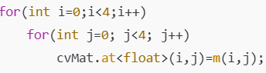

A nested loop iterates over each element of the 4x4 matrix. The at<float>(i,j) and m(i,j) function accesses the element at row i and column j of the respective matrix and while storing double is converted to float. And the function returns a copy (deep copy) of the created Matrix.

1. cv::Mat Converter::toCvMat(const Eigen::Matrix<float,4,4> &m)

This function converts an **Eigen 4x4 matrix of type float** into an **OpenCV 4x4 matrix of type float (CV_32F)**. This is similar to the function for a double Eigen matrix but tailored for float matrices.

* 1. Input:

m is a 4x4 matrix from the Eigen library with elements of type float.

* 1. Create an OpenCV Matrix:



This initializes an cv::Mat object with dimensions 4x4 and data type CV_32F ( a matrix of floats).

* 1. Copy Data:



A nested loop iterates over each element of the 4x4 matrix. The at<float>(i,j) and m(i,j) function accesses the element at row i and column j of the respective matrix. And the function returns a copy (deep copy) of the created Matrix.

1. cv::Mat Converter::toCvMat(const Eigen::Matrix<float,3,4> &m)

This function converts an **Eigen 3x4 matrix of type float** into an **OpenCV 3x4 matrix of type float (CV_32F)**.

* 1. Input:

m is a 3x4 matrix from the Eigen library with elements of type float.

* 1. Create an OpenCV Matrix:



This initializes an cv::Mat object with dimensions 3x4 and data type CV_32F ( a matrix of floats).

* 1. Copy Data:

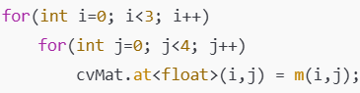

A nested loop iterates over each element of the 3x4 matrix. The at<float>(i,j) and m(i,j) function accesses the element at row i and column j of the respective matrix. And the function returns a copy (deep copy) of the created Matrix.

1. cv::Mat Converter::toCvMat(const Eigen::Matrix3d &m)

This function converts a **3x3 Eigen matrix of type double** into a **3x3 OpenCV matrix of type float (CV_32F)**

* 1. Input:

m is a 3x3 matrix from the Eigen library with elements of type double.

* 1. Create an OpenCV Matrix:



This initializes an cv::Mat object with dimensions 3x3 and data type CV_32F ( a matrix of floats).

* 1. Copy Data:

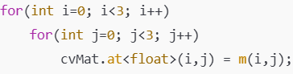

A nested loop iterates over each element of the 3x3 matrix. The at<float>(i,j) and m(i,j) function accesses the element at row i and column j of the respective matrix. And the function returns a copy (deep copy) of the created Matrix.

1. cv::Mat Converter::toCvMat(const Eigen::Matrix3f &m)

This function converts a **3x3 Eigen matrix of type float** into a **3x3 OpenCV matrix of type float (CV_32F)**.

* 1. Input:

m is a 3x3 matrix from the Eigen library with elements of type float.

* 1. Create an OpenCV Matrix:



This initializes an cv::Mat object with dimensions 3x3 and data type CV_32F ( a matrix of floats).

* 1. Copy Data:



A nested loop iterates over each element of the 3x3 matrix. The at<float>(i,j) and m(i,j) function accesses the element at row i and column j of the respective matrix. And the function returns a copy (deep copy) of the created Matrix.

1. cv::Mat Converter::toCvMat(const Eigen::MatrixXf &m)

This function converts a **dynamic-size Eigen matrix of type float** (Eigen::MatrixXf) into a **dynamic-size OpenCV matrix of type float (CV_32F)**.

* 1. Input:

m is a dynamically sized Eigen matrix where the number of rows and columns can vary with elements of type float.

* 1. Create an OpenCV Matrix:



This initializes an cv::Mat object with same number of rows and columns as input and data type CV_32F ( a matrix of floats).

* 1. Copy Data:

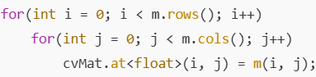

A nested loop iterates over each element of the input matrix. The at<float>(i,j) and m(i,j) function accesses the element at row i and column j of the respective matrix. And the function returns a copy (deep copy) of the created Matrix.

1. cv::Mat Converter::toCvMat(const Eigen::MatrixXd &m)

This function converts a **dynamic-size Eigen matrix of type double** (Eigen::MatrixXd) into a **dynamic-size OpenCV matrix of type float (CV_32F)**.

* 1. Input:

m is a dynamically sized Eigen matrix where the number of rows and columns can vary with elements of type double.

* 1. Create an OpenCV Matrix:



This initializes an cv::Mat object with same number of rows and columns as input and data type CV_32F ( a matrix of floats).

* 1. Copy Data:



A nested loop iterates over each element of the input matrix. The at<float>(i,j) and m(i,j) function accesses the element at row i and column j of the respective matrix. And the function returns a copy (deep copy) of the created Matrix.

1. cv::Mat Converter::toCvMat(const Eigen::Matrix<double,3,1> &m)

This function converts a **3x1 Eigen vector of type double** into a **3x1 OpenCV matrix of type float (CV_32F)**.

* 1. Input:

m is a 3x1 matrix from the Eigen library with elements of type double.

* 1. Create an OpenCV Matrix:



This initializes an cv::Mat object with dimensions 3x1 and data type CV_32F ( a matrix of floats).

* 1. Copy Data:

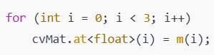

A nested loop iterates over all 3 element of the matrix. Copies each element m(i) from the Eigen vector to the corresponding position in the OpenCV matrix cvMat.at<float>(i), converting the data type from double to float. And the function returns a copy (deep copy) of the created Matrix.

1. cv::Mat Converter::toCvMat(const Eigen::Matrix<float,3,1> &m)

This function converts a **3x1 Eigen vector of type float** into a **3x1 OpenCV matrix of type float (CV_32F)**.

* 1. Input:

m is a 3x1 matrix from the Eigen library with elements of type float.

* 1. Create an OpenCV Matrix:



This initializes an cv::Mat object with dimensions 3x1 and data type CV_32F ( a matrix of floats).

* 1. Copy Data:



A nested loop iterates over all 3 element of the matrix. Copies each element m(i) from the Eigen vector to the corresponding position in the OpenCV matrix cvMat.at<float>(i). And the function returns a copy (deep copy) of the created Matrix.

1. cv::Mat Converter::toCvSE3(const Eigen::Matrix<double,3,3> &R, const Eigen::Matrix<double,3,1> &t)

This function converts an Eigen representation of a **3D rigid transformation (SE(3))** into a **4x4 OpenCV homogeneous transformation matrix** of type CV_32F. It combines a 3x3 rotation matrix (R) and a 3x1 translation vector (t).

* 1. Create a 4x4 Identity Matrix



Initializes a 4x4 OpenCV matrix as an identity matrix with type CV_32F. The identity matrix acts as the base, and we fill in the rotation and translation values.

* 1. Copy Rotation Matrix (R) into the Top-Left 3x3 Block

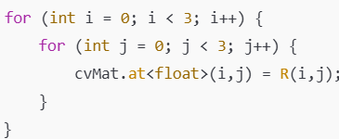

Iterates over the 3x3 elements of the Eigen rotation matrix R and copies them into the top-left 3x3 submatrix of cvMat.

* 1. Copy Translation Vector (t) into the Right-Most Column

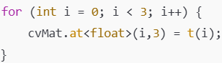

Copies the elements of the Eigen translation vector t into the last column (excluding the bottom-most row) of the OpenCV matrix. And then the copy (deep copy) of the matrix is returned as output.